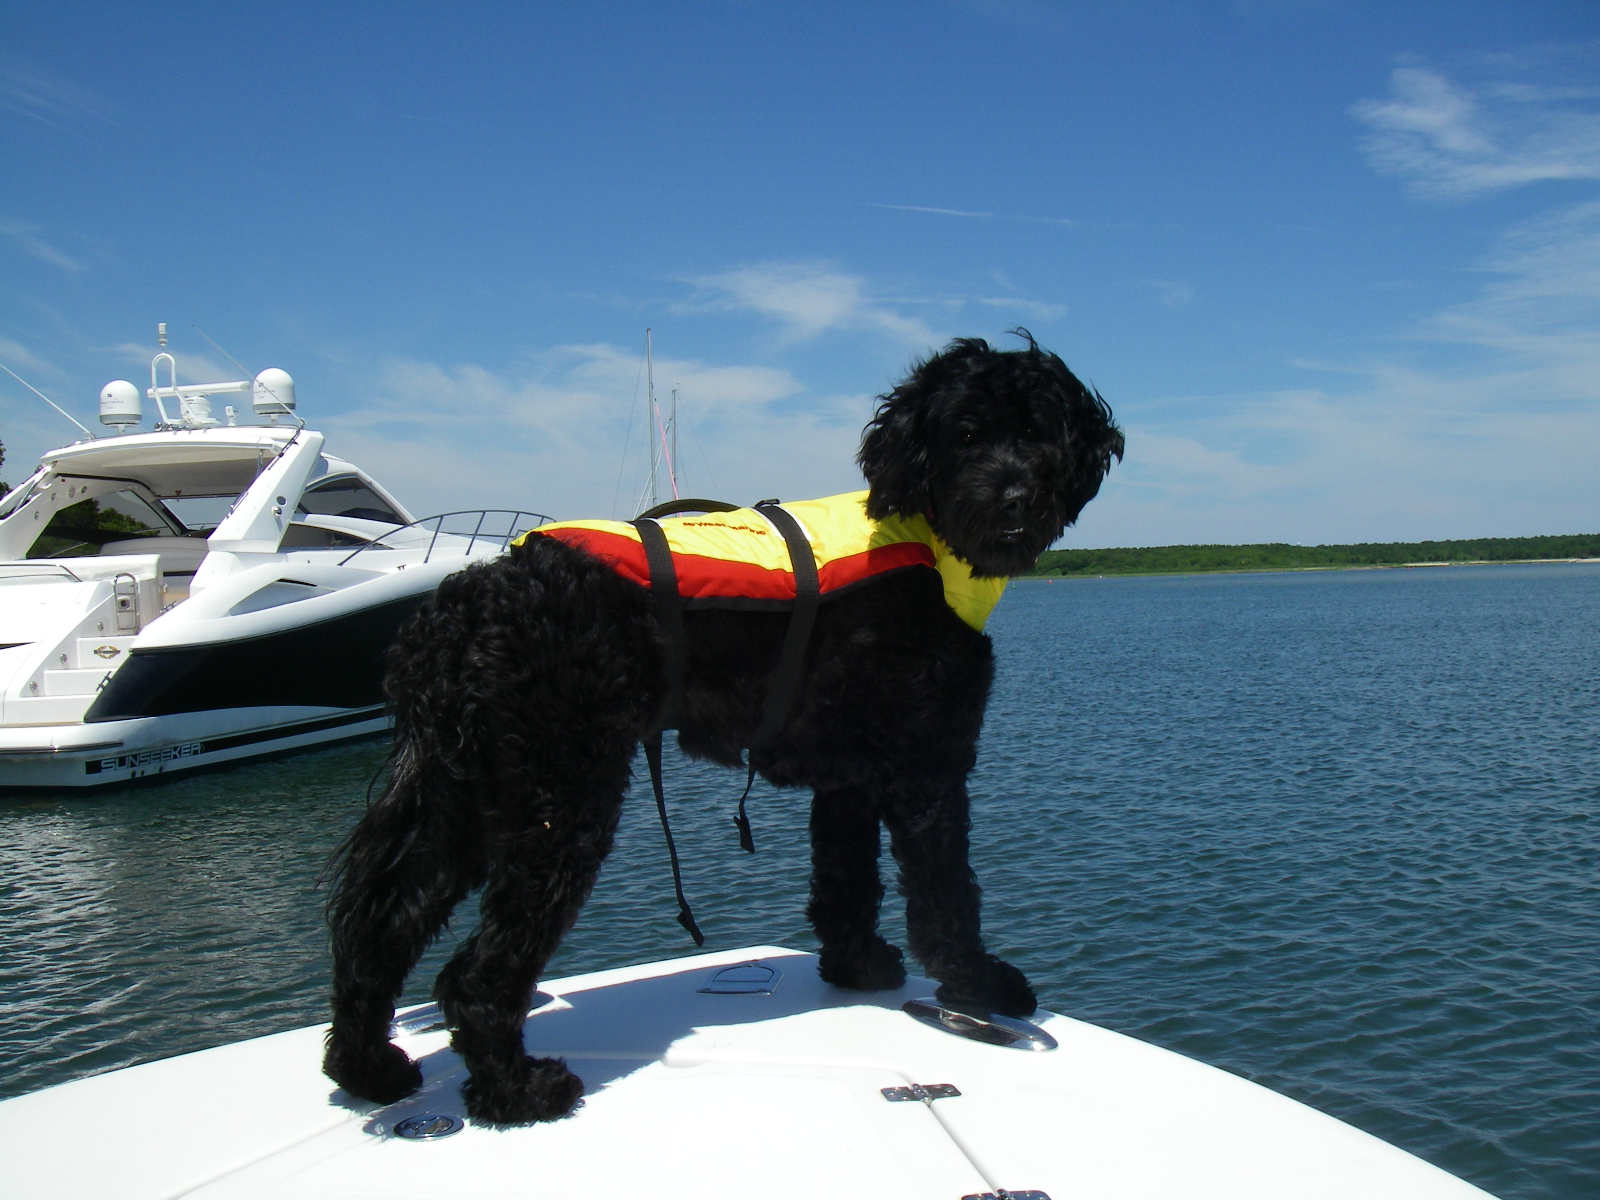

Salt Heir Portuguese Water Dogs

22 East Street

Sudbury, MA 01776

978-443-8291 or 508-494-3332

leg70@aol.com

VACCINES: Your puppy received his/her first vaccinations. These are detailed on the vaccination record form contained in your puppy packet. Please show this to your veterinarian. No additional vaccines are required for at least 2 weeks.

WORMING: Your puppy was wormed at 2, 3,4,6 weeks of age using Pyrantel pamoate. Please take a stool sample to your vet during the next 1 - 2 weeks, and have your vet check the stool again.

THE FOLLOWING ARE SOME SUGGESTIONS FOR MAKING YOUR PUPPY’S TRANSITION INTO YOUR HOME A LITTLE EASIER...

1. Your puppy has been eating Royal Canin medium breed puppy food. It is important that you continue to feed this food to your puppy while he is adjusting to your home. If you decide to switch to another brand, do it slowly, by mixing both kibbles together, slowing decreasing one, while increasing the other. It is not necessary to feed Puppy formula of any kind after 4 months.

Feed your puppy 3 times a day at first. Serve 1/2 a cup at each feeding. Your puppy will let you know if he/she wants more than that amount as time goes on. You can add a bit of meat and a small amount of some well cooked, mashed vegetables. Your puppy will love it, and it should not turn him into a fussy eater.

Fresh water should be available to the puppy until about 8:30 pm, then take it up for the evening to prevent “tanking up.” If you crate your puppy during the day, leave about 1 cup of water in a tip proof container, e.g. a 1 qt. stainless steel bucket with a bolt snap to hold the bucket in place. Collars off when in the crate! Unless you are right there to supervise because ID tags can get caught in the spaces between the wires.

2. Every time your puppy wakes up and every time your puppy has eaten or had a drink of water, you should take your puppy outside immediately. This will avoid many accidents. Be sure to praise the puppy after he/she relieves himself/herself outside, and reward with a small treat. You can easily train your puppy to go on command simply by saying something like “get busy” or “hurry up” just at the point in time when the puppy relieves himself/herself. Your puppy will learn this quite quickly. I recommend setting a timer for 45-minute intervals. When the timer sounds, it’s time to take the puppy out! You can increase the time intervals as the puppy grows and progresses.

I believe that you will find it useful to have an indoor X-Pen (for playing without supervision) and an outdoor X-Pen as the “potty area.” You may find it useful to place a sheet of newspaper in the outdoor X-Pen to help your puppy get the idea that is the place that he should relieve himself. Blankets, other bedding, toys and such should be in the inside X-Pen, and your puppy can play and nap here or in his crate.

The X-Pens should be at least 36” high. Higher is better. I purchase mine from Pet Edge. They have a web site (www.petedge.com) and you can also pick them up at the Pet Edge Warehouse in Billerica, MA with 24 hour advanced notice. Dog.com (www.dog.com) also has a very good web site and ships things out quickly, and charges a reasonable price for shipping.

3. You may also wish to purchase 1 or 2 small plastic or wire crates, i.e. 1 for riding in the car, and the other for sleeping in your room at night. The most economical plastic crates can be purchased at Wal Mart or K Mart, while the most economical wire crates can be purchased at Pet Edge in Billerica, MA or from Dog.com. (I have recently seen some wire crates at Wal Mart which are priced competitively with Dog.com and Pet Edge.) A crate measuring approximately 20” wide X 30” long is about the right size for now, or you can purchase a larger crate with a dividing panel which you can move as the puppy grows larger.

NOTE: If you are going to leave the puppy alone for a long day, find someone you trust to check in on him/her at least once during the day, to feed and exercise the puppy. Leaving a puppy alone in a crate for 8-9 hours without an opportunity for a good break every 4 hours is cruel and could teach the puppy to use his crate as a bathroom.

4. Your puppy has already been receiving corrections for biting hands and pulling on clothing. You need to continue to follow through. There are many techniques available, and you may want to begin (at least for the first day or so) by distracting the puppy with a suitable toy. Getting up from the floor and turning your back on the puppy can give him/her a strong message that you won’t play the nipping game. Consider “time outs” by simply picking the puppy up and placing her in her crate for a bit with a nice chew toy. The crate is not a punishment unless you make it one. Give her a toy and some peace and quiet for a bit, and play later. Whatever you do, don’t make this a game. Your puppy is bound to win! You can find more information on this subject at the following URL:

http://www.clickertraining.com/node/168

A printed copy of this article is included in your puppy pack.

DO NOT ALLOW CHILDREN TO DISCIPLINE OR TEASE THE PUPPY EVER!! Teach your children not to snatch things (including hands!) away from him. This will only teach the puppy to grab and nip more forcefully the next time. Teach the children and the puppy to “Trade” and then to “Drop” on command. This will take some time and supervision on your part, and you will need to be patient. Once the puppy will “Drop” an item reliably for an adult, then you may begin teaching the children to use this technique.

The nipping and grabbing behavior usually subsides around 4 months or so, provided it is not inadvertently rewarded, i.e. you’re not clear and consistent about your expectations and the puppy is allowed to “win.” It’s a long wait...

5. It is very important to puppy proof your home, not only for yourself, but also for the puppy’s safety. Get down on the floor at the puppy’s level and pick up anything you can, especially if it is made of wood. You can use a pastry brush to paint Tabasco Sauce on the bottom of the legs of all of your wooden chairs, or you can spray Bitter Apple or Phooey/Fooey on wooden surfaces. The sauce shows up clear and yet delivers a subtle message to a very mischievous pup. Some dogs love the taste of either or both of these substances however...

6. Make sure you buy your puppy LOTS of chew toys and a couple stuffed animals of his/her own. I use rawhide only until the puppy has his/her second teeth, and then no more. Mature Water Dogs will ingest enormous amounts of rawhide in a very small amount of time, and this can result in an intestinal blockage.

NEVER USE CHEW HOOVES after your puppy has her second teeth! It is very easy to break off large chards of the hoof and, just like a goat, your puppy will swallow them. These can do serious damage both to the intestine or the esophagus if vomited back up. I find smoked shin bones or marrow bones warmed in the microwave work well. Remove the marrow and stuff the end with peanut butter. Kong toys are popular too. You can stuff them with biscuits and things like spray cheese from a can, or the Kong stuffings which come in peanut butter and liver flavor.

Tennis balls (wash in the washing machine first to remove most of the dye) are fun for your puppy, and if your puppy takes after Mom and Pop, he/she may shred the cover off of the ball, so beware, and don’t allow it.

Booda Bones are also good diversions provided you do not let the puppy play alone with it. They will chew the strings up and swallow them. If you see your puppy doing this, take the Booda Bone away.

PIG EARS contain bacteria that can cause severe diarrhea and/or gastroenteritis. DO NOT GIVE THEM TO YOUR PUPPY! THEY ARE NOT SAFE.

7. Try not to play roughly with the puppy. Puppies love this game, but it does teach them to become unruly, and they will often start to nip in order to initiate play or to “win” the game. This is not acceptable. There are lots of ways to play with the puppy that do not involve rough housing or tug of war. This type of play can lead to an accidental injury to a child and/or the puppy.

8. Try to include the puppy in as many activities as possible. This is an important part of the puppy’s socialization. Remember, if you leave the puppy in the car, even for a few minutes, it is best to crate him/her as you could easily come back to a ruined vehicle. Your puppy’s grandfather ate the gear shift knob (a $25 item) 4 times when he was younger. (I’m a slow learner). Be careful not to leave your puppy in a car in the hot sun!

You want the pup to grow up to be friendly with other dogs. Try to provide the pup with an opportunity to socialize with other dogs, but make certain you know the dog will be friendly with pups and is properly vaccinated. This is most easily accomplished by enrolling your puppy in a Puppy Kindergarten, and I highly recommend that you sign up for such a class as soon as possible. You and your puppy will benefit greatly from the experience.

9. The adults in the home are responsible for training the puppy, and it’s a very good idea to have a plan of action in terms of training your puppy before he/she arrives home. If you’ve had success with a trainer in the past, then by all means contact that trainer again and get your puppy enrolled in a training class before he/she comes home. I strongly recommend that you consider Clicker Training your puppy. Getting Started Clicker Training For Dogs by Karen Pryor is an excellent paperback book that you can purchase online at: http://www.clickertraining.com/store/ or by phoning 1-800-47-CLICK.

10. Establish the rules right up front, and be FIRM, FAIR AND CONSISTENT with your puppy. You and your puppy will be happiest when you are. Some examples of the “House Rules:”
- To discourage mealtime begging, the puppy will not be fed from the table.
- The puppy will not be allowed up on the furniture.
- The puppy will not be allowed to jump up on people who come to the door
- The puppy will sleep in a crate
- The puppy will not be encouraged to bark excessively.
Remember: If you don’t want your puppy to exhibit unacceptable behaviors as an adult, then prevent them from happening while he/she is young. Don’t ever give your puppy more freedom (e.g. “the run of the house”) than he/she is capable of dealing with. Out-of-sight typically translates to: “in trouble.” Purchase a baby gate or two from Toy’s R Us or from Dog.Com. There are many different types, including pressure gates that don’t require permanent mounting.

REMEMBER ALSO: If you have any questions, PLEASE, PLEASE contact me as soon as you feel the need! I will maintain an interest in this puppy for his/her entire lifetime.

