Salt Heir Portuguese Water Dogs
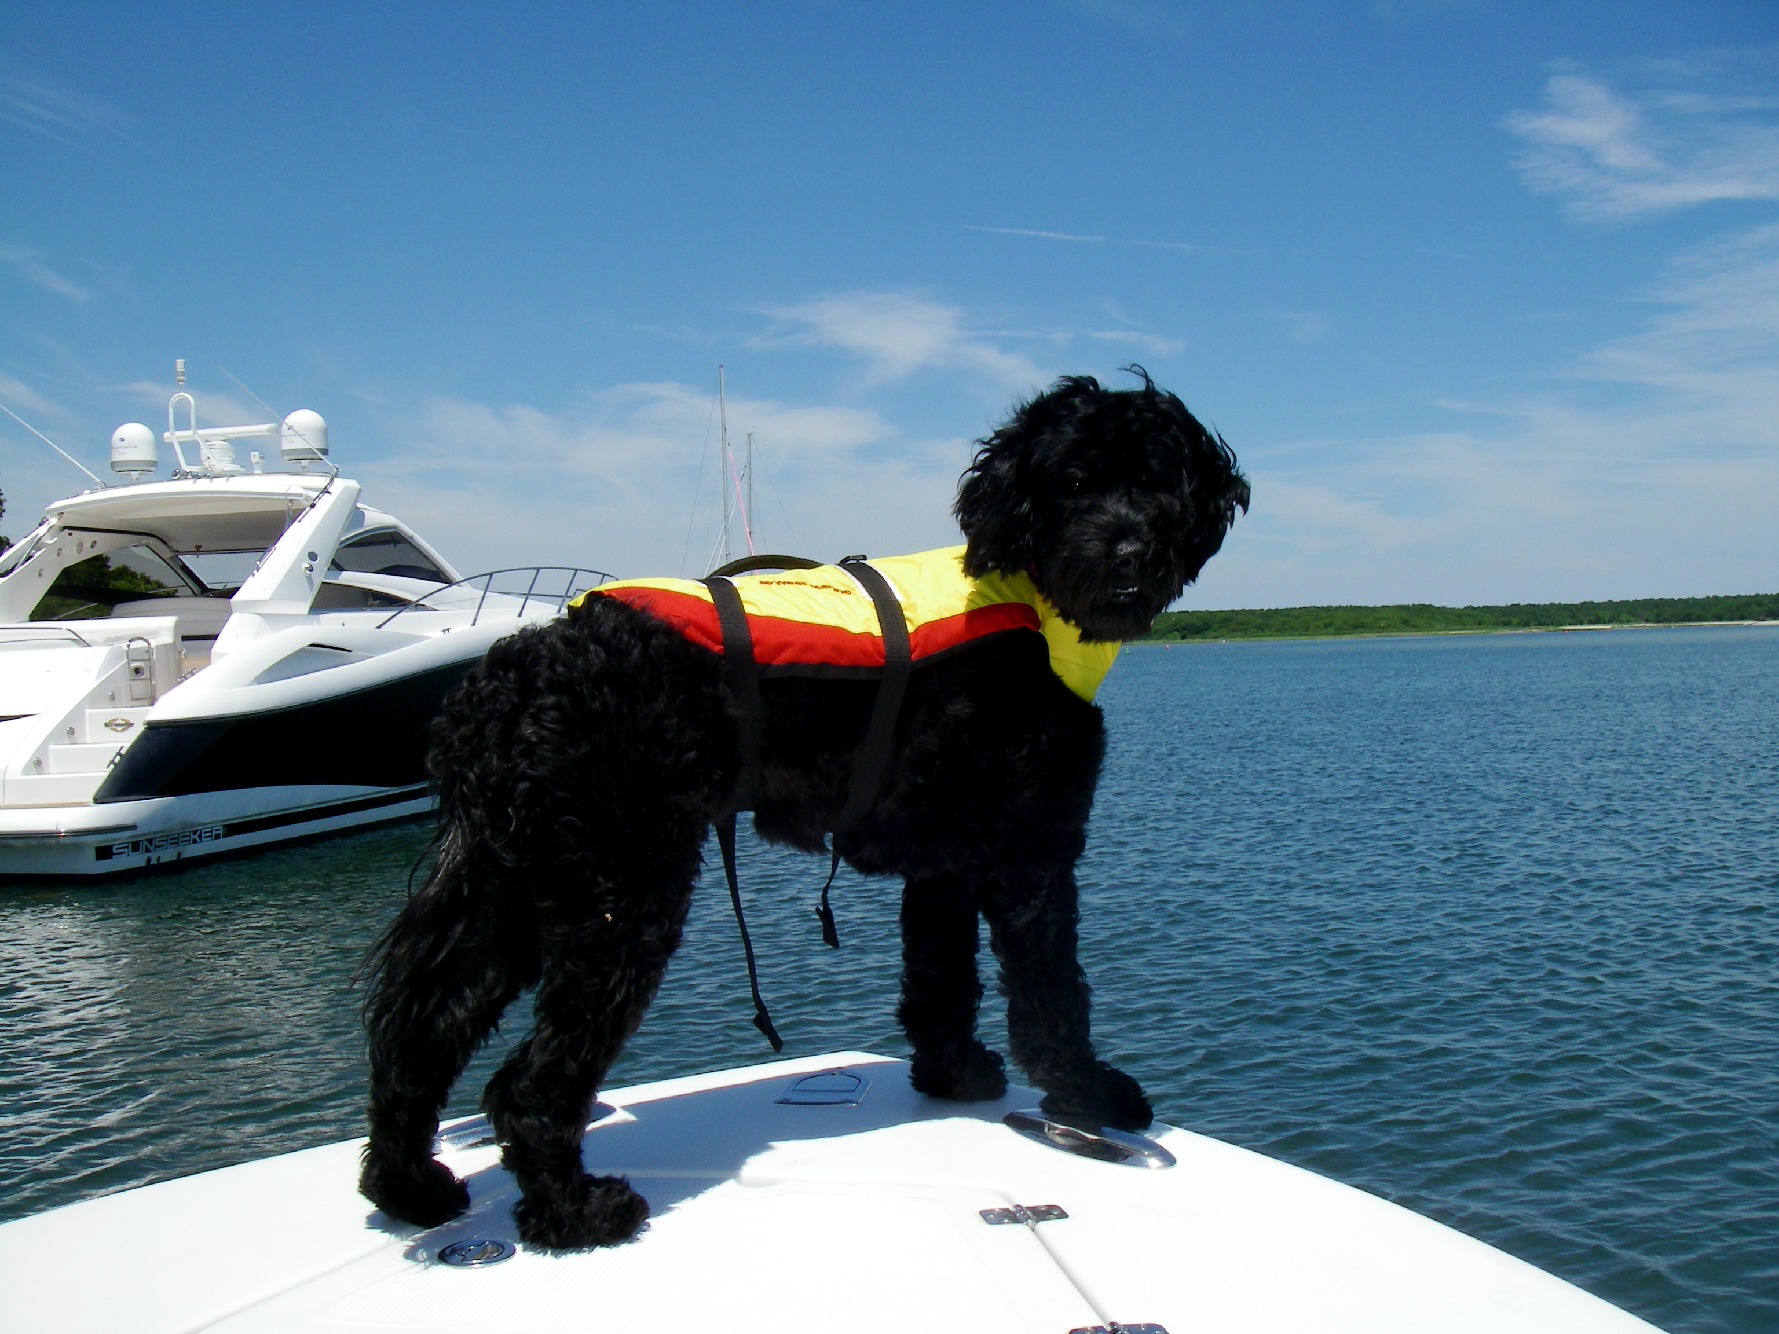
Puppy Buyer Questionnaire

The following questions will help us to determine the best puppy for you.
Do the best you can in answering the questions. There is no right or wrong answer.
We require this application of all people interested in an Salt Heir PWD Puppy.

Name: E-mail Address:
Address:
Day Phone Number: Evening Phone Number:
Family Information:

1. Are you married? How many adults live in your home?

2. Do you have any children? Ages of children in the home:

3. What activities do you enjoy in your spare time?

4. Do all members of your family want to get a puppy?

5. Do any family members have allergies to dogs?

6. Who will be the primary care giver for your puppy?

7. Have you ever owned a dog before? What happened to that dog?

8. Have you ever given a dog away or taken one to a pound or shelter?
If so, what was the circumstance?

9. If your family circumstances change (new baby, change of residence or job), what will happen to the dog?

10. Do you currently own any other pets?

11. Do you have a veterinarian? If so, please provide name, address, and phone number.

Housing Information:
1. Do you live in a house/apartment/condo/townhouse?

2. If renting, do you have your landlord’s permission to have a dog? Please list landlords name, address,
and phone number:

3. Do you have a yard? If so, how large? If not, how do you plan to exercise your dog?

4. Is your yard completely fenced with secure fencing? How high?

5. If not, would you be willing to do so before bringing home a new puppy or build a secure run for the puppy to be in when not being safely supervised for its safety?

6. Do you have a swimming pool? Is it fenced off?

Puppy Information:
1. Why have you decided to buy a Portuguese Water Dog?

2. Are you aware of health problems that may affect a Portuguese Water Dog?

3. Are you familiar with the temperament of a Portuguese Water Dog. They are high energy, spirited, intelligent and obedient for those it works for. They are chewers and diggers, especially if they are left alone for extended periods of time?

4. Do you prefer male/female?

5. Please rank the following factors in order of importance to you in your choice of a puppy
(1 = most important):
Structure/Looks
Temperament
Sex
Potential Obedience/Agility Dog
Family Companion
Potential Show Dog
Potential Breeding Animal
Pet Therapy
Search & Rescue
4H or FFA project
Other

6. Where will your dog live (inside, outside, combination of both)?

7. Is anyone home during the day? How many hours on the average will your dog spend alone?

8. Will there be someone available to feed and exercise the puppy during the day?

9. Where will your puppy spend the time when no one is at home?

10. Where will your puppy stay if you go out of town?

11. Where will the puppy sleep at night?

12. Have you thought about how you are going to housebreak the puppy?

13. Are you going to crate-train your puppy?

14. Are you willing to take your puppy to obedience classes?

15. Have you completed any AKC titles on other dogs?
If so please describe:

16. Is this your first puppy or the first one in many years?

17. Do you plan to spay or neuter your puppy?

18. If this is a show puppy, please list some references (i.e., breeders, trainers, vets, etc.)

19. Have you ever bred a dog/dogs before?
If so please elaborate:

20. If you have other show puppies, please list and state from whom they were purchased.

21. If this is a show puppy, will you be showing it yourself or will you be hiring someone to show for you?

22. How did you hear about our kennel?

ALL PUPPIES ARE SOLD ON LIMITED REGISTRATION
To promote responsible breeding, all of our puppies are sold on a Limited Registration basis. Limited
Registration means that the dog is eligible for registration with the American Kennel Club; however, any offspring
produced by the dog would not be eligible to be registered with the AKC. This does not mean that the dog is of
lesser quality. It just means that they are ineligible to enter conformation shows or produce registered offspring.
They are eligible to enter other AKC events such as hunt tests, agility, obedience & rally trials. Most puppies
purchased from Salt Heir PWD are purchased as companion dogs by owners who have no interest in breeding or showing; therefore, limited registration will have no bearing on these dogs and their owner.

However, should an owner decide to become involved with showing and/or breeding in the future, limited registration will be a factor. When and if certain necessary criteria are met by the dog and owner, Salt Heir PWD can remove the limited designation and allow full registration of the dog. Show potential puppies are sold with a co-ownership agreement in place.

Now it is your turn to ask me questions or tell me more about yourself and your family. The more the better!

Please send this back to me at your convenience.

Thank you for your interest!

Lynn Green
Salt Heir Portuguese Water Dogs
22 East Street
Sudbury MA, 01776
978-443-8291

